Prediction and Preparedness
Proposed Article for Domestic Preparedness Journal

Civil unrest situations, regardless of cause, create unexpected risks to lives and property. Predicting the timing and scale of these events would surely be part of a domestic preparedness process, allowing for better tactical management and, over the long term, a more effective training process. But, theoretical work by complex systems scientists as well as real-world experiences of first responders make a strong case that forecasting the timing and especially the character of civil unrest may be impossible. Still, recent advances in understanding complex systems can provide profound contributions to the preparation community.
Many researchers have come to focus on the concept that some natural world systems are complex and adaptive and that these systems share universal properties regardless of their character. Complex adaptive systems include markets, national and local economies, political movements, ecosystems, revolutions and insurgencies, crowds, and – for the DOMPREP community – civil unrest and riots. Several institutions have evolved in the 21st century to study complexity, the prominent examples including the Santa Fe Institute, the Center for the Study of Complex Systems at the University of Michigan, and the Center for Social Complexity at George Mason University. The patterns in complex systems are more than the sum of their parts. In fact, the pattern that emerges – recessions, riots, or revolutions – can’t be understood or predicted in the traditional way: breaking the systems down into individual parts.
What’s more, the adaptive character of individuals makes such systems impossible to predict. In traditional systems like a car, a factory, or a computer, past performance can be analyzed statistically to predict future behavior. Given the same inputs, the system (most of the time) produces the same output. The adaptivity in complex adaptive systems means that the individuals learn, plan, anticipate, adjust, and react. Thus, when the same inputs, the same policies, the same interventions are applied, the system will not respond in the same way.
What does this mean for DOMPREP planners? The most important implication – and one that all good police departments understand – is the need to expect the unexpected, managing each situation in its own context. DOMPREP planners have to think more like stock traders than like airline pilots. Their “system” – a neighborhood of people with many backgrounds, cultures, and ages – is never going to be predictable. For that reason, it is probably impossible to create a “flight simulator” for a civil disturbance response situation. And, the constant adaptation means that people’s attitudes about police changes daily. The same event that triggered no public response in March might create intense, destructive protests in May, and vice versa.
There are many other situations in which public planners must operate without the ability to predict. The precise timing and location of large earthquakes or winter storms (beyond a few weeks) are good examples. What precursors that exist are unreliable, producing more false alarms than accurate warnings. As in these examples, propagating a false alarm about impending civil unrest among the public or even only in official channels can cause more harm than good. It creates a “numbness” and an unwillingness to act decisively in the face of a real violent incident.
If traditional prediction is not appropriate for the onset of civil unrest, how can planners plan? One of the most effective tools is the inclusion of a broad, diverse range of thinkers in the strategic planning team. University of Michigan researcher Scott Page has generated an excellent body of thought that helps guide the creation of more adaptive and effective management teams – especially in the face of complex adaptive systems. If you look around at your community engagement team and find that everybody shares the same background, the same education, the same knowledge base, you may want to consider drawing in people who think differently and who draw from different experiences.
Another key element in managing the unknown is the need for constantly evolving sources of information. Decision-makers often get “channel-locked” into looking at particular indicators that, while appropriate for a time, become ineffective sensors of the overall situation. You may be looking at the spread of graffiti or monitoring specific points in social media. But, weeks and months later, these no longer connect with the flow of public attitudes. Eventually, everybody realizes that such things are monitored and move to other channels of information flow.
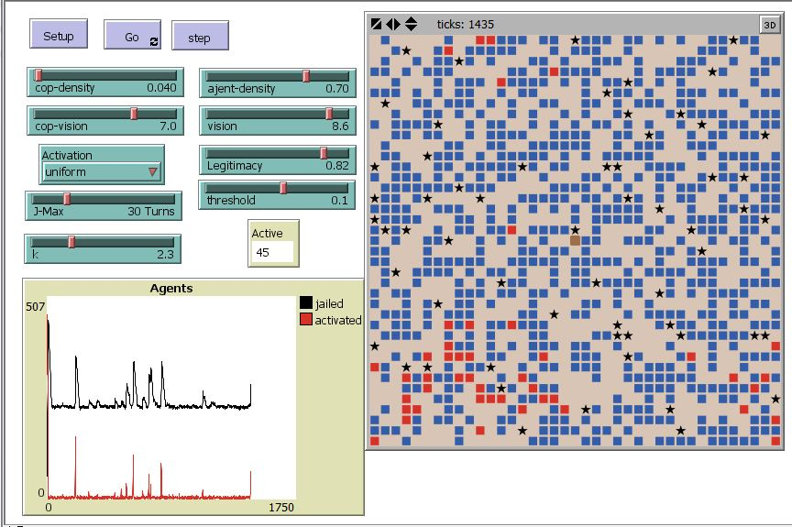
The third component that complexity scientists have found effective is the use of simulation – sometimes called a “computational” approach because of the leverage provided by modern computer systems and object-oriented software. Crowds and communities are far too complex to simulate precisely, but much progress has been made by a “divide and conquer” approach. By simulating simple components of human behavior, such as the belief in the legitimacy of government or the level of “grievance”, scientists have been able to replicate the unpredictable bursts of violence.
Prominent mathematician George Box famously wrote, “All models are wrong. Some are useful.” An agent-based model of civil unrest is certainly “wrong” in the sense that it fails to include the many factors that constitute a neighborhood. Streets and buildings, for example, are not depicted and do not constrain the movement of people. Such models can’t determine the precise optimum number of police patrols necessary to suppress violence. They can help, however, guide an assessment of risk. If properly validated, models and simulations can show the impact of doubling police patrols or cutting them in half. They can also suggest whether there is a point of diminishing returns, where adding or reducing police patrols makes no difference.
Complex adaptive systems, therefore, require a complex adaptive response. Diversity in thinking and experience in the strategic planning team helps to harness the power of creativity and evolving ideas. An adaptive situational awareness process is vital to avoid drawing information from obsolete or misleading sources. Just as important is the need to apply this creativity and adaptivity to the response system. Method of community engagement are vital to managing good police-community relations, but they lose their effectiveness in time. This requires a process of constant innovation and adaptation. Such a process is intuitive and difficult to formalize, train for, and even describe and define. It’s part of the “blue sense” that comes from front-line experience.
The good news is that the strategic approach on the part of first responders has evolved to encompass many of these concepts. Successful police leaders realize the simple fact that they are never “done”. There is no permanent solution, no “best practice” that will create a permanent solution. Instead, they must be constantly innovating, avoiding unproductive mindsets, and questioning assumptions. New ideas can come from a variety of sources: within the force, the community, other DOMPREP professionals, academia, the military, or even international sources.
These are the early days in understanding how to manage complex adaptive systems. The techniques presented here, and others, are under active development by economists, market analysts, the insurance industry, public policy designers, traffic engineers, the military, and cyber-security professionals – just to mention a few who recognize the unique challenges of complexity. New concepts and ideas surface all the time, and many communities learn from one another. The cross-pollination is enabled by a growing community of academic researchers, who experiment with new ways to analyze the massive data associated with these large-scale systems. In the coming years it is highly likely that DOMPREP planners with be able to draw from these successes and significantly improve the ability to plan for and adapt to the challenge of “black swan” events.

